SAINT ROSE OF LIMA
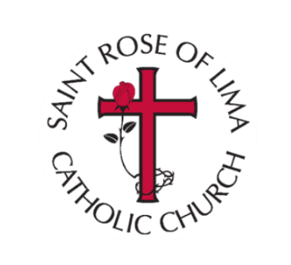
Faith Formation Advisory Committee
2021-2022
Mary Wentworth, Chair
Celeste Hannan
Molly Meyer
Tom Ring
Patty Wolters
Ashley Brooks
Matt Cain, Parish Council Liaison

